**Project Report**

Arputharaj P: 711120243002

Deenadhayaalan M: 711120243012

Deepak C:711120243013

Sanjay Kumar G: 711120243041

Yogesh K:711120243060

**Introduction:**

* 1. **Overview:**

Creating a reel design in Canva is a user-friendly process. Start by selecting the Instagram Reels template, then customize it with your media, text, graphics, and music. Canva's tools make it easy to arrange and animate your elements. Once satisfied, export the reel in the desired format and share it on your favorite social media platforms, like Instagram, to captivate your audience with engaging, visually appealing content.

* 1. **Purpose:**

The purpose of our project to build a website using Canva is to create a professional-looking and easy-to-manage website without any coding experience. Canva is a popular graphic design platform that offers a variety of templates and design elements that make it easy to create a website that is both visually appealing and informative.

**Problem Definition and Design Thinking:**

**2.1 Empathy Map:**

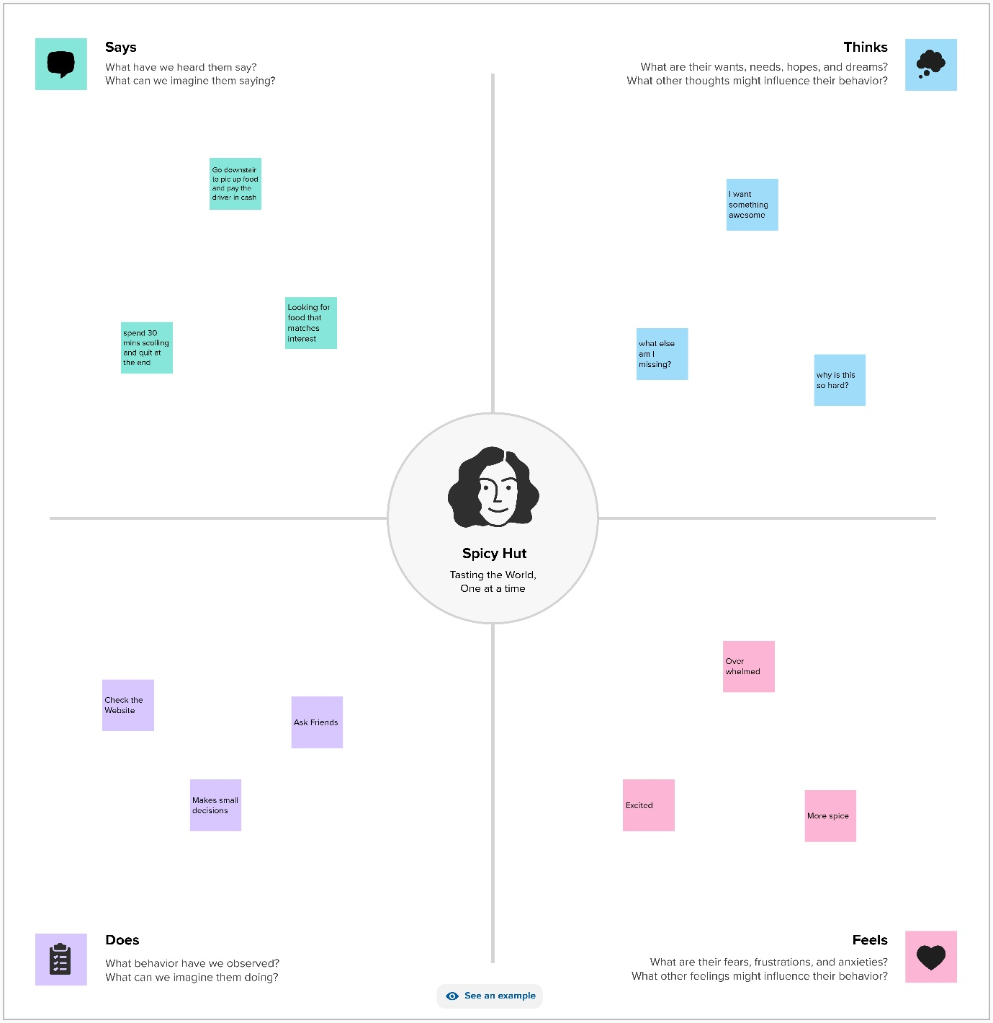

**2.2 Ideation and Brainstorming:**

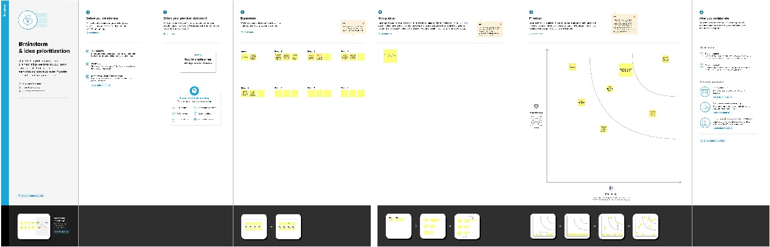

**3. Result**

The Reel called **Fire Hut**  is created using canva. Below are the Reel pages from

the Instagram:

**First page:**

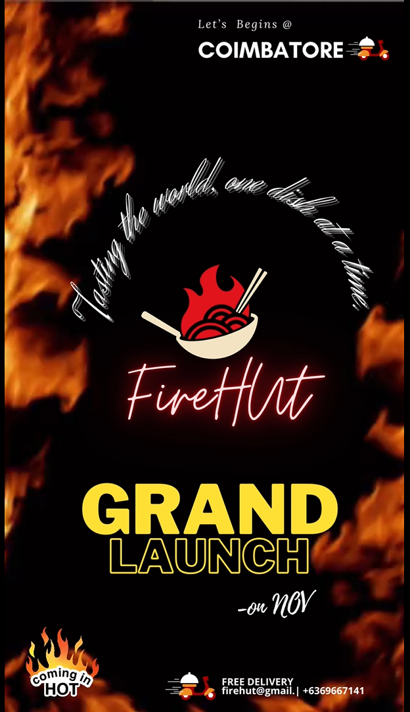

**Food Page:**

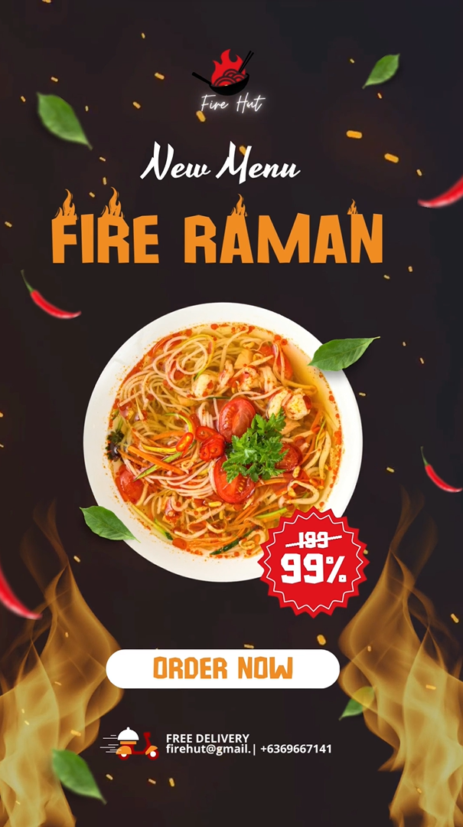

**Spl..Food Page:**

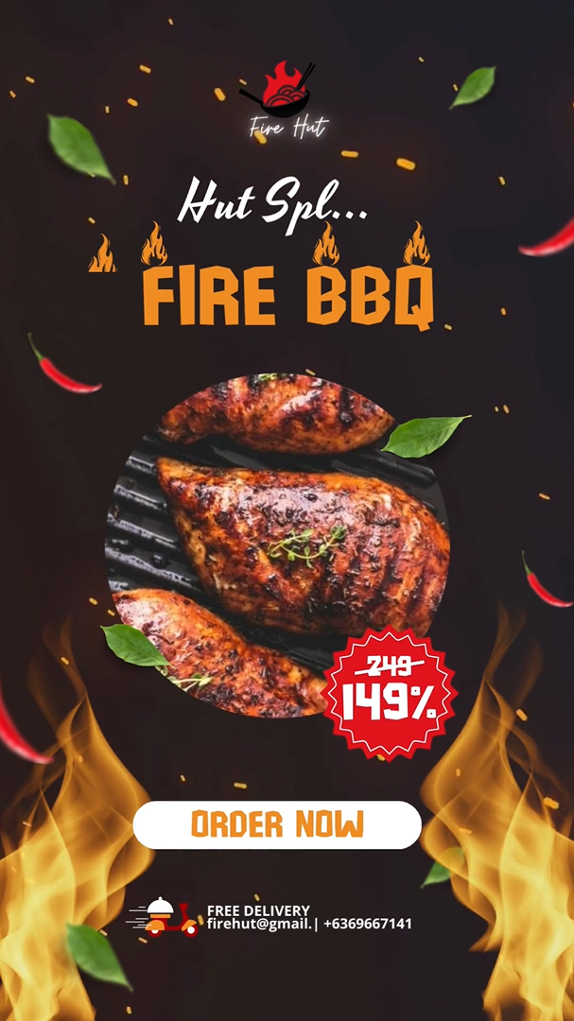

**Hot Food Page:**

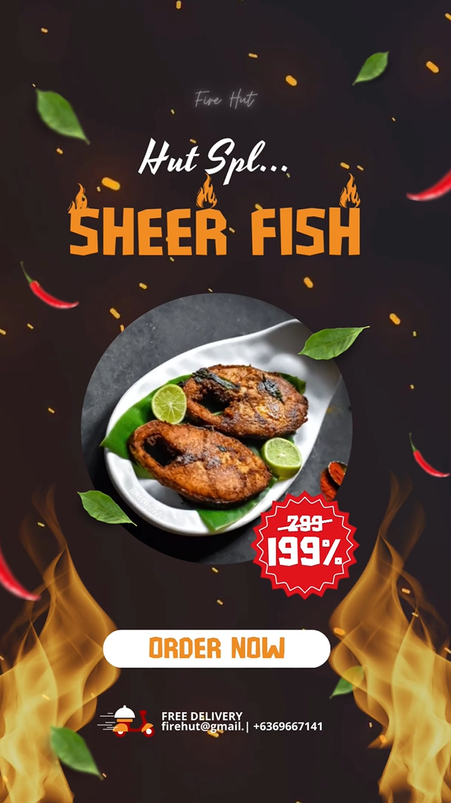

**Hot Drink Page:**

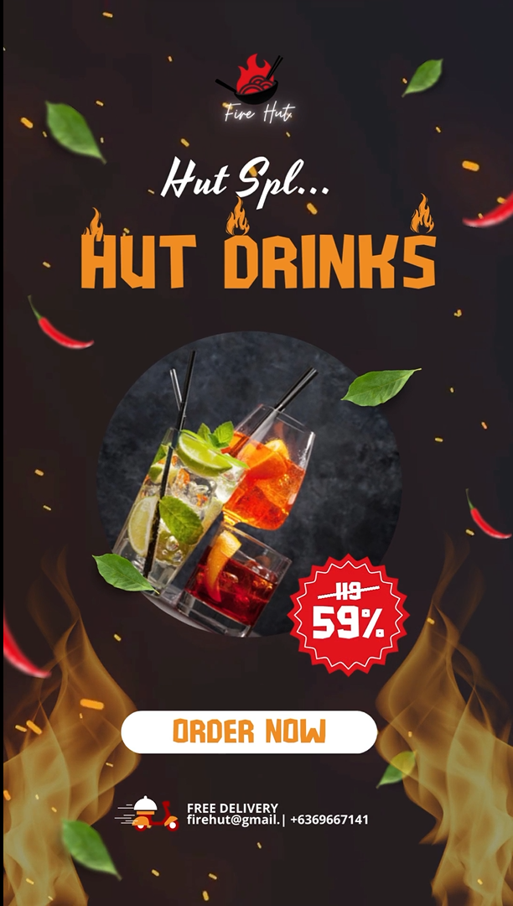

**Order Page:**

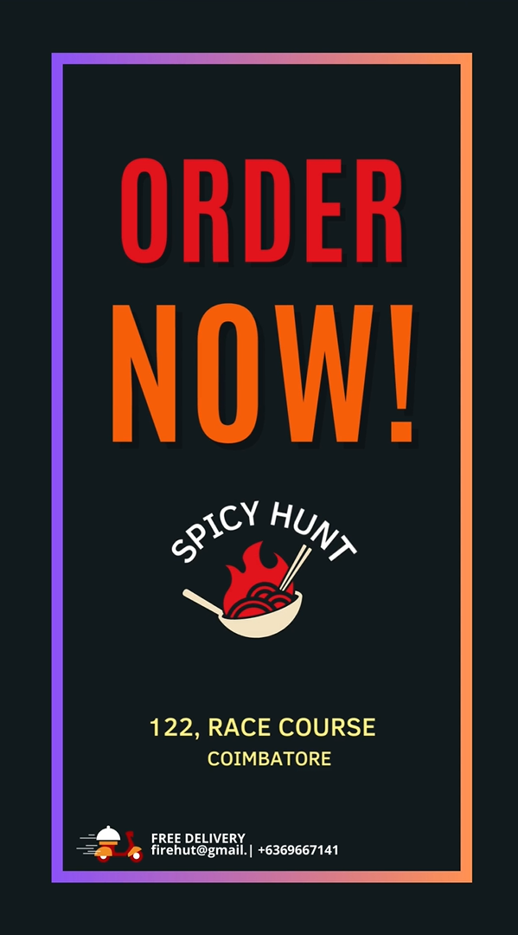

**4. Advantages:**

* **Enhanced Flavor**: Heat intensifies the flavors in many dishes, making them more enjoyable and appealing to the palate
* **Improved Digestibility**: Heat can break down complex molecules in food, making it easier for the body to digest and absorb nutrients.
* **Kills Harmful Microorganisms**: Cooking at high temperatures can kill harmful bacteria and parasites that may be present in raw food, reducing the risk of foodborne illnesses.
* **Increased Food Safety:** Hot food is less likely to harbor pathogens or spoil quickly, improving food safety and reducing the risk of foodborne illnesses.

**Disadvantages:**

* Nutrient Loss: High temperatures during cooking can lead to the degradation of certain vitamins and minerals, reducing the nutritional value of the food.
* Potential Formation of Harmful Compounds: Cooking at high temperatures, especially with certain cooking methods like grilling or frying, can lead to the formation of potentially harmful compounds, such as acrylamide, heterocyclic amines, and polycyclic aromatic hydrocarbons.

**5. Applications**

* Food Blogs and Vlogs
* Restaurant and Food Business Promotion
* Cooking Tutorials
* Food Photography and Styling
* Recipe Sharing
* Diet and Nutrition Content
* Food Reviews and Critiques
* Culinary Challenges
* Food Product Marketing
* Cultural and Regional Cuisine
* Food Education

**6. Conclusion**:

In conclusion, Canva offers an accessible and versatile platform for creating compelling reel designs. With its user-friendly interface, customizable templates, and an array of creative tools, you can easily craft engaging short video content. Whether for personal projects, social media marketing, or storytelling, Canva simplifies the process, making it accessible to individuals and businesses alike, enabling them to capture their audience's attention and convey their messages effectively through visually captivating reels.